Set

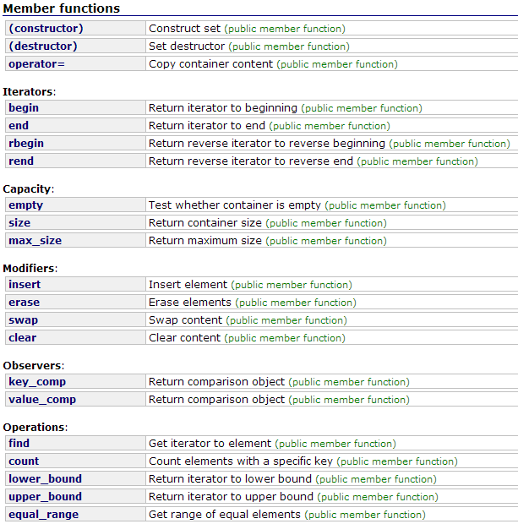

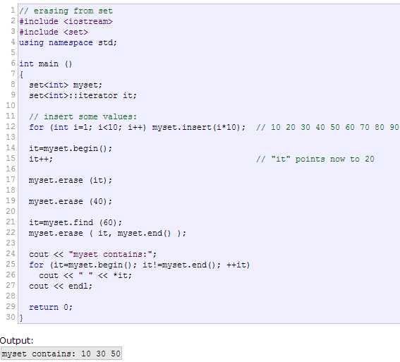

Queue

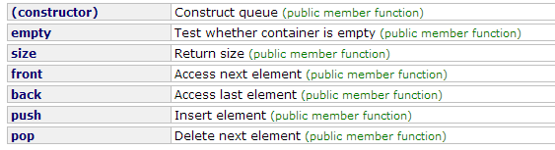

Priority_queue

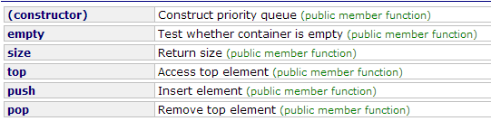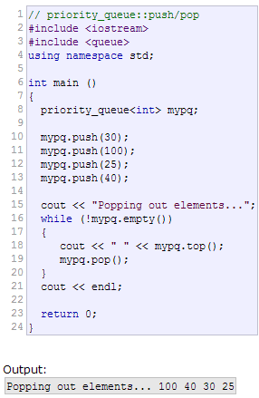

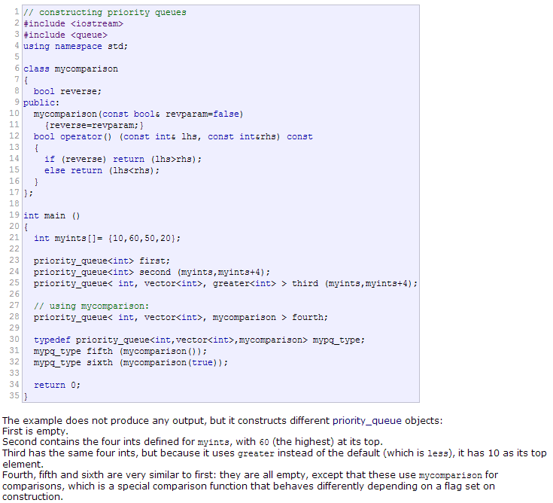

List

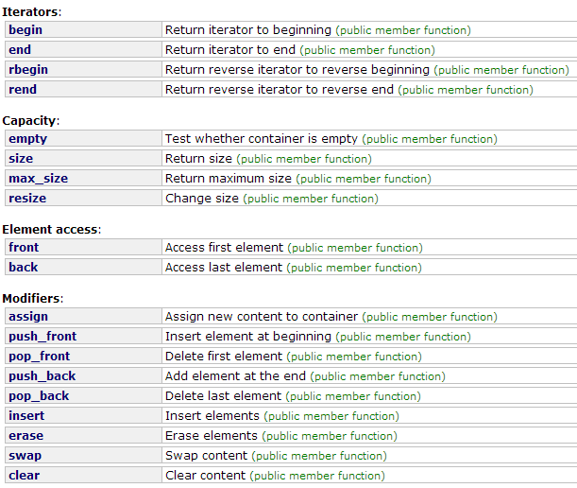

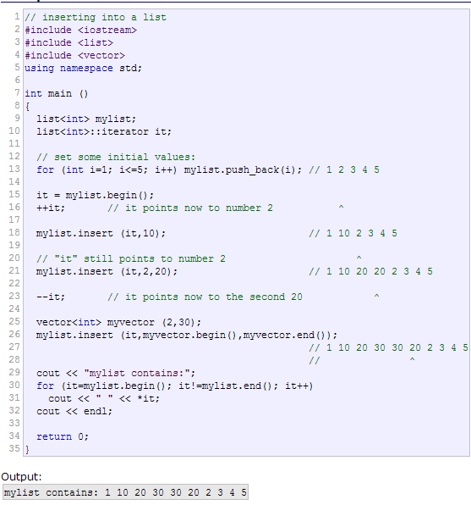

Stack

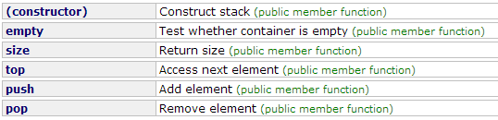

Vector

vector< vector< pair< pair<int, int>, int> > > g;

g.push_back( vector< pair< pair<int, int>, int> > () );

g.push_back( vector< pair< pair<int, int>, int> > () );

g[association[a]].push_back( make_pair( make_pair(c.size(), (int)c[0]), association[b]) );

g[association[b]].push_back( make_pair( make_pair(c.size(), (int)c[0]), association[a]) );

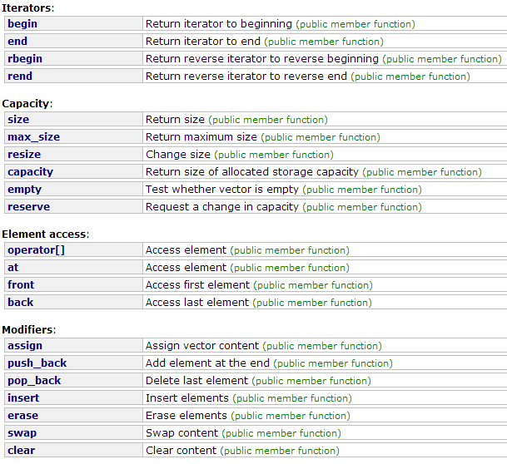

Algorithm

Prim – árvore geradora minima (dark roads)

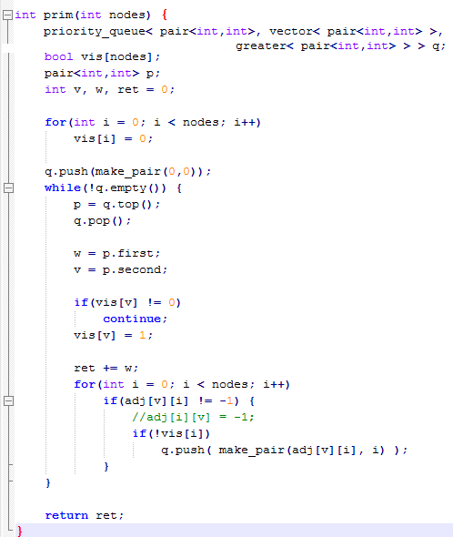

Floyd – menores caminhos no grafo

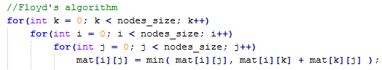

Dijkstra – menor caminho entre dois véetices

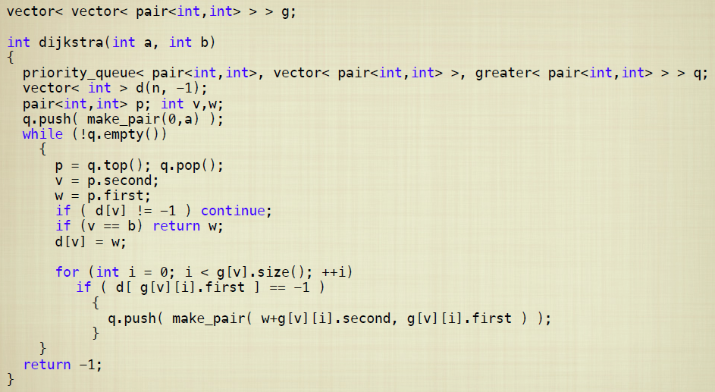

Programa bicoloring

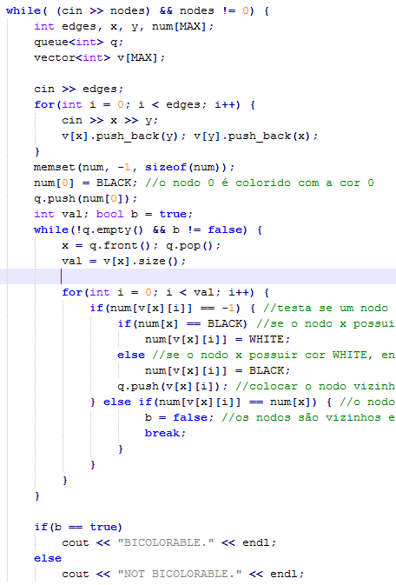

EOF

